Sharing and Binding within High-Level Synthesis
Oluwasholape Oyemade
Department of Electronic Engineering
Hochschule Hamm-Lippstadt
Lippstadt, Germany
sholapeoyemade40@gmail.com
Abstract—High-Level Synthesis (HLS) transforms behavioral descriptions into Register Transfer Level (RTL) hardware implementations. A central problem in this process is the efficient use of functional units and storage elements under timing and resource constraints. This paper studies sharing and binding within HLS. Resource sharing is described as the reuse of hardware units by operations whose executions do not conflict, while binding is the synthesis step that assigns operations and variables to resource types and resource instances. The paper presents the mathematical basis of the binding problem using operation graphs, execution intervals, compatibility relations, conflict graphs, and graph coloring. Based on Teich and Haubelt, binding after scheduling is formulated as interval graph coloring and solved using the LEFTEDGE algorithm. The runtime and hardware overhead of this approach are analyzed. A compact C++ implementation demonstrates the core binding mechanism, and a four-tap finite impulse response filter is used as an application example. The final RTL realization shows how sharing decisions introduce multiplexers, registers, functional units, and control logic.
Index Terms—High-Level Synthesis, resource sharing, binding, graph coloring, LEFTEDGE, RTL generation.

I. INTRODUCTION
High-Level Synthesis (HLS) is a design methodology that transforms a behavioral description into a hardware implementation at Register Transfer Level (RTL). Instead of manually describing every register, multiplexer, and control state, the designer starts from an algorithmic model and synthesis procedures derive a hardware architecture [1], [2]. This raises the abstraction level of hardware design and makes it possible to explore several architectures before implementation.
The quality of the generated architecture depends on three closely related decisions: when operations execute, which resources exist, and which operation is assigned to which resource. Teich and Haubelt identify allocation, scheduling, and binding as fundamental synthesis tasks. At the architectural level, operations such as additions and multiplications are tasks, while adders, multipliers, registers, buses, and memories are resources [1].
This paper focuses on sharing and binding within HLS. Sharing reduces hardware cost by allowing compatible operations to reuse the same resource. Binding determines the resource instance on which each operation or variable is implemented. The two concepts are inseparable: sharing is the optimization objective, while binding is the assignment process that realizes this objective in the datapath and controller.
The contribution of this paper is a focused explanation of the mathematical basis, algorithmic formulation, runtime implications, C++ implementation, application use, and RTL consequences of sharing and binding. The discussion is centered on binding after scheduling, because this case leads to interval graphs and the LEFTEDGE algorithm, a clear and exact method for resource binding [1].
II. MATHEMATICAL FOUNDATIONS
A. Operation Graphs and Resources
The behavioral input to HLS is commonly represented by a data-flow graph (DFG) or a control-data-flow graph (CDFG). A DFG is defined as G = (V, E), where V is the set of operation nodes and E is the set of dependency edges. A node represents an arithmetic, logical, or memory operation. An edge indicates that the result of one operation is required before another operation can execute [1], [3].
Let O = {op1, op2, ..., opn} be the set of operations and R = {r1, r2, ..., rm} be the set of hardware resources. Resources are typed. For example, an addition operation must be mapped to an adder or an arithmetic logic unit, while a multiplication operation must be mapped to a multiplier or another compatible functional unit. This distinction matters because only operations of compatible resource type can share the same instance.
B. Scheduling and Binding Functions
Scheduling assigns each operation to one or more clock cycles. For operation opi, the execution interval is denoted by T(opi). Binding assigns the operation to a concrete resource instance. Formally, binding can be expressed as
B: O -> R. (1)
The binding function is valid only if no two overlapping operations are assigned to the same non-pipelined resource instance. Therefore, two operations can share a resource only when they require the same resource type and their execution intervals are disjoint:
T(op_i) ∩ T(op_j) = ∅. (2)
This condition explains why scheduling and binding are coupled. Scheduling determines temporal overlap; binding exploits non-overlap to reuse resources. If two operations execute in the same control step, they require separate resource instances. If their intervals are disjoint, they may share one instance.
III. SHARING AND BINDING IN HIGH-LEVEL SYNTHESIS
A. HLS Flow
The HLS flow can be summarized as behavioral description, scheduling, allocation, binding, and RTL generation, as shown in Fig. 1. Scheduling decides execution time, allocation determines the available resource types and quantities, and binding maps operations and variables to these resource instances [1], [4].
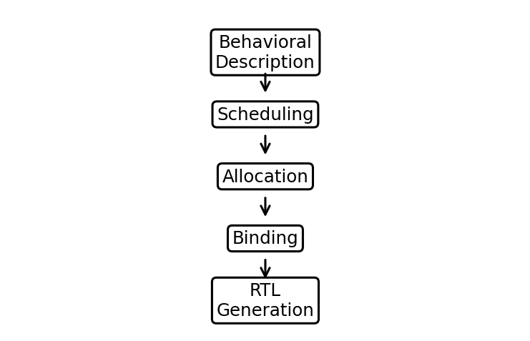
Fig. 1. Simplified HLS flow from behavioral description to RTL generation.
B. Resource Sharing
Resource sharing is the reuse of hardware units by multiple operations. Instead of assigning a dedicated functional unit to every operation, compatible operations may use the same adder, multiplier, divider, register, or memory element. The purpose is to reduce hardware area and improve utilization. Fig. 2 shows the difference between a dedicated-resource implementation and a shared-resource implementation.
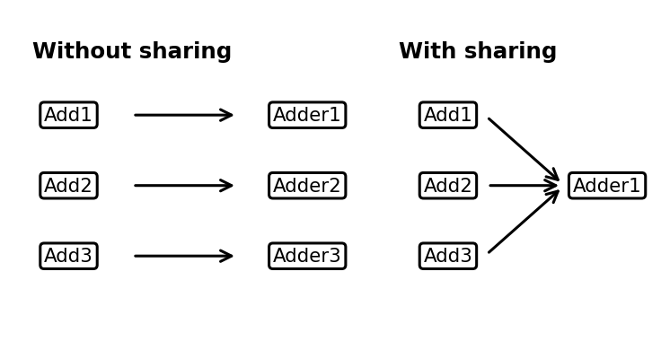
Fig. 2. Functional unit sharing: multiple additions can reuse one adder if they execute at different times.
Functional unit sharing applies to arithmetic and logical units. For example, three additions do not automatically require three adders. If the additions are scheduled in different cycles, a single adder can execute all of them. This reduces area, but it also requires multiplexers to select operands and a controller to activate the correct operation at the correct time.
Register sharing applies to storage elements. Variables whose lifetimes do not overlap can be stored in the same register. This is similar to register allocation in compilers, but in HLS it affects the physical storage elements of the generated datapath. Register sharing reduces storage cost and can also reduce interconnect complexity when performed carefully.
A simple lifetime example shows the same principle for storage resources. If variable x is produced in cycle 1 and last used in cycle 3, while variable y is produced in cycle 4 and last used in cycle 6, their lifetimes do not overlap. Both values can therefore be stored in one physical register. If the lifetimes overlap, two registers are required. Register binding is therefore another graph-based resource sharing problem, but the nodes represent values or variables rather than arithmetic operations.
This distinction is important because sharing does not only reduce arithmetic units. It also affects the storage structure and the number of data transfers in the generated datapath. Poor register binding may reduce the number of registers but increase multiplexing or routing cost.
C. Binding as the Mechanism of Sharing
Binding is the synthesis task responsible for realizing sharing. Teich and Haubelt define binding as the decision specifying on which resource type and on which resource instance a task is implemented. Binding may be performed before scheduling, after scheduling, or together with scheduling [1].
The relation between sharing and binding is direct. Sharing defines the opportunity: multiple operations may reuse the same resource. Binding makes the decision: these operations are assigned to the same resource instance. A paper on sharing without binding would only describe a goal; a paper on binding without sharing would miss why the assignment problem matters.
It is also useful to separate resource-type binding from resource-instance binding. Resource-type binding decides whether an operation is implemented by a multiplier, ALU, memory, or another component type. Resource-instance binding decides which concrete instance of that type is used. Sharing occurs at the instance level when several compatible operations are mapped to the same physical unit.
IV. GRAPH-THEORETIC BINDING ALGORITHM
A. Compatibility Relations
Teich and Haubelt formulate binding problems using graph theory. Two nodes are compatible if they can be implemented on the same resource type and if their executions do not overlap. The book distinguishes weak compatibility, schedule compatibility, and strong compatibility. For the binding-after-scheduling case, schedule compatibility is central because the execution intervals are already known [1].
Compatibility is recorded in a compatibility graph. The vertices are operations and an edge connects two operations that may share a resource. A set of mutually compatible operations forms a clique. Therefore, cost-optimal binding can be viewed as partitioning the compatibility graph into a minimum number of cliques [1].
B. Conflict Graph and Coloring
The complementary formulation is the conflict graph. Here an edge connects two operations that cannot share a resource. In this representation, binding becomes a graph coloring problem. Adjacent vertices must receive different colors, and each color corresponds to one resource instance. Minimizing the number of colors minimizes the number of resource instances needed for that resource type [1].
This formulation is useful because it connects binding to well-known combinatorial optimization problems. In general graphs, optimal graph coloring is difficult. However, the binding-after-scheduling case has additional structure because operations are represented by time intervals.
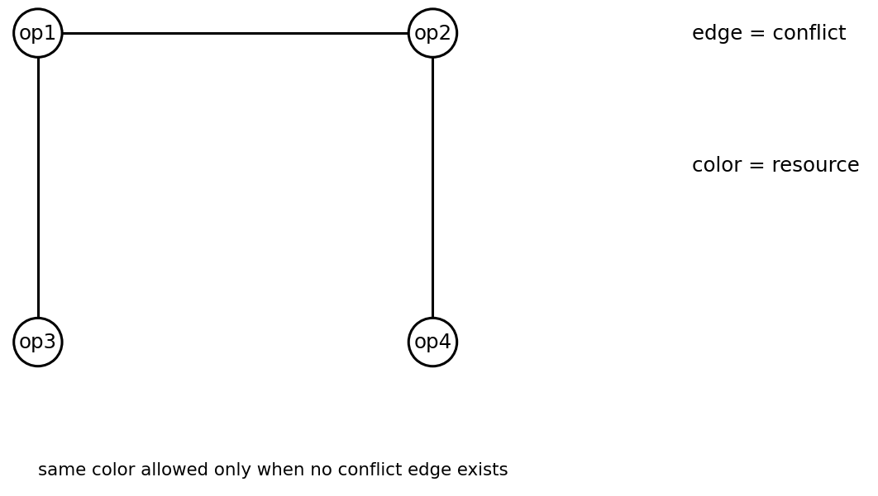
Fig. 3. Conflict graph interpretation of binding: connected operations cannot use the same resource instance.
C. Interval Graphs and LEFTEDGE
After scheduling, each operation vi has an interval Ii = [li, ri), where li is the start time and ri is the finish time. Two operations conflict if their intervals overlap and they require the same resource type. The resulting conflict graph is an interval graph [1].
For interval graphs, Teich and Haubelt present the LEFTEDGE algorithm. The algorithm sorts all intervals by increasing left boundary and repeatedly forms sets of non-overlapping intervals. Each set receives one color, which represents one hardware resource. The algorithm is exact for interval graphs and runs in O(|V| log |V|), where |V| is the number of operation intervals [1].
LEFTEDGE(intervals):
sort intervals by start time
color = 0
while intervals not empty:
color = color + 1
r = 0
for each interval I in order:
if start(I) >= r:
assign color to I
r = finish(I)
remove I from intervals
return colors
The output of LEFTEDGE is a color assignment. In the hardware interpretation, each color is a concrete resource instance. Thus, all operations with the same color are bound to the same functional unit or storage resource, provided they belong to the same resource type.
A small interval example clarifies the mapping from colors to resources. Assume five multiplication operations have execution intervals I1 = [1, 3), I2 = [3, 5), I3 = [2, 6), I4 = [6, 8), and I5 = [5, 7). LEFTEDGE first chooses non-overlapping intervals beginning with the earliest left edge. One possible coloring is shown in Table III. Operations with the same color are executed on the same resource instance.
This example also shows why resource count is tied to overlap. Even if all five operations are of the same type, overlapping intervals cannot use the same physical multiplier. The number of colors is the number of resource instances needed for that type.
V. RUNTIME AND OVERHEAD ANALYSIS
A. Algorithmic Runtime
The computational cost of binding after scheduling is dominated by sorting the execution intervals. Therefore, LEFTEDGE runs in O(|V| log |V|). This cost is acceptable because HLS is a design-time process. The generated embedded system does not execute the binding algorithm at runtime; it only executes the resulting RTL architecture [1].
B. Hardware Effects
The primary hardware benefit is area reduction. Without sharing, every operation may require a dedicated functional unit. With sharing, operations that do not overlap can be mapped to the same instance. This reduces multipliers, adders, registers, or other resources depending on the operation type.
The cost is structural overhead. Shared functional units require multiplexers to select operands, registers to store intermediate values, and a controller to activate resources at the correct cycle. Therefore, sharing reduces arithmetic resources but may increase interconnection and controller complexity [2], [4].
C. Design Interpretation
Resource sharing is not automatically beneficial in every design. If latency is the primary constraint, aggressive sharing may be unsuitable because fewer resources reduce available parallelism. If area or cost is the primary constraint, sharing is attractive because it reduces the number of instantiated units. The designer must therefore interpret binding results with respect to area, latency, energy, and control complexity.
VI. C++ IMPLEMENTATION
The implementation demonstrates the main feature of binding: checking whether scheduled operations overlap and assigning compatible operations to shared resources. It is intentionally compact and does not implement a complete HLS tool.
struct Op { string name; int start, finish; };

bool conflict(const Op& a, const Op& b) {
return !(a.finish <= b.start || b.finish <= a.start);
}

for (Op& op : operations) {
bool assigned = false;
for (Resource& r : resources) {
if (!conflictsWithAssignedOps(op, r)) {
r.bind(op); assigned = true; break;
}
}
if (!assigned) resources.push_back(Resource(op));
}
The code uses the same principle as interval-based binding. If a new operation does not conflict with operations already assigned to a resource, it can be bound to that resource. Otherwise, a new resource instance is created. In a full HLS tool, this logic would be integrated with resource-type checks, scheduling constraints, and RTL code generation.
VII. APPLICATION EXAMPLE: FIR FILTER
A four-tap finite impulse response (FIR) filter is a suitable application example because it contains repeated multiplications and additions. Its output can be written as
y[n] = Σ_{i=0}^{3} h_i x[n-i]. (3)
A fully parallel implementation uses four multipliers for the four coefficient products. This gives high throughput but consumes more area. If the schedule allows multiplication operations to occur in different cycles, binding can assign multiple multiplication operations to fewer multiplier instances.
For example, assume Mul1 and Mul2 execute in different cycles, and Mul3 and Mul4 also execute in different cycles. A possible binding is Mul1, Mul2 -> Multiplier1 and Mul3, Mul4 -> Multiplier2. The number of multipliers is reduced from four to two. This is sharing at the functional-unit level and binding at the resource-instance level.
The example demonstrates the central tradeoff of the paper. Resource sharing reduces the number of hardware instances, but binding creates a more serialized datapath. The final architecture is still functionally equivalent to the original algorithm, but its timing and control behavior differ from a fully parallel implementation.
VIII. RTL REALIZATION
The output of HLS is an RTL structure consisting of a datapath and a controller. When sharing is used, the datapath contains shared functional units, multiplexers, registers, and control signals. The controller selects operands and enables registers according to the schedule [2], [6].
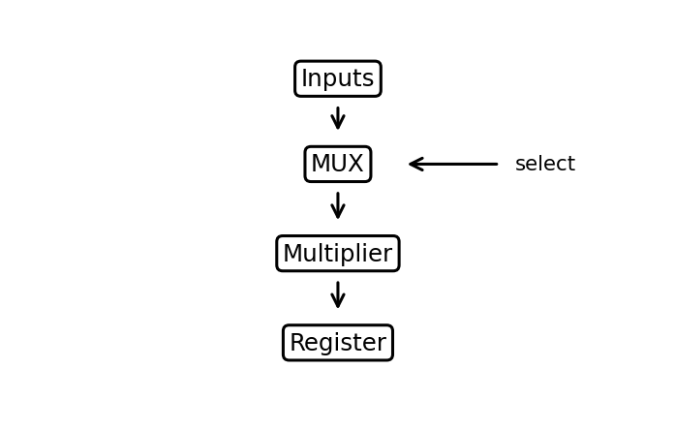
Fig. 4. Simplified RTL structure created by binding multiple operations to one shared multiplier.
For the FIR example, two multipliers may replace four dedicated multipliers. The generated RTL must then include multiplexers to route the correct operands to each multiplier. The binding map therefore determines the structural form of the datapath. The controller must ensure that the selected operands correspond to the operation scheduled in the current control step.
This is the practical consequence of binding. The decision is not only an abstract mapping from operations to resources. It directly changes the RTL netlist by altering the number of functional units, the number of multiplexers, the register structure, and the control logic. A different binding can therefore lead to a different hardware cost even when the behavioral algorithm is unchanged.
IX. DISCUSSION
A. Suitable Use Cases
Sharing and binding are especially suitable for area-constrained designs where the maximum throughput requirement is moderate. Embedded controllers, sensor-processing blocks, and low-cost FPGA designs often benefit from using fewer functional units. In such cases, a slightly longer schedule can be acceptable if it significantly reduces the number of instantiated adders, multipliers, or registers.
The method is also useful when the scheduled operation intervals are already known. This is the case considered by the LEFTEDGE formulation. The problem becomes structurally clearer because every operation has a start time and finish time, allowing conflicts to be represented as interval overlaps.
B. Limitations
The approach is less suitable when the design requires maximum parallelism or strict low-latency execution. If several operations must execute in the same clock cycle, they cannot share the same non-pipelined resource. For such designs, aggressive sharing can increase latency and reduce throughput.
Another limitation is that the algorithmic model captures resource conflicts, but the final quality of the RTL implementation also depends on interconnect cost, multiplexer depth, control complexity, and technology-specific timing. Therefore, an optimal binding with respect to resource count is not always globally optimal with respect to timing, power, or place-and-route behavior.
This means that sharing and binding should be evaluated as part of a design-space exploration process rather than treated as an isolated optimization. A resource-minimal solution may be attractive mathematically, but the best engineering solution depends on the complete set of area, latency, and implementation constraints.
C. Design-Space Implications
The final RTL architecture therefore reflects a chain of decisions rather than one isolated optimization. The behavioral description defines the operations, scheduling defines their timing, binding defines the resource mapping, and RTL generation materializes the decision as functional units, registers, multiplexers, and control states.
This also explains why sharing and binding cannot be treated independently from scheduling. A schedule with many simultaneous operations limits sharing opportunities, while a schedule spread over more cycles creates more compatible intervals. In practice, HLS tools often explore several schedules and bindings to find an acceptable area-performance tradeoff.
The binding result should be interpreted as one point in the HLS design space. A design with more sharing generally uses fewer resources, while a design with less sharing generally exposes more parallelism. The best architecture depends on the design objective. For a low-cost controller, area reduction may dominate. For a high-throughput signal-processing block, latency and initiation interval may dominate.
X. CONCLUSION
This paper examined sharing and binding within HLS. Sharing reduces hardware resources by reusing functional units and registers across compatible operations. Binding is the synthesis task that assigns operations and variables to specific resource instances and therefore realizes sharing in the generated architecture.
Using Teich and Haubelt, binding after scheduling was described as a graph-theoretic problem. Compatibility graphs, conflict graphs, graph coloring, interval graphs, and the LEFTEDGE algorithm provide a formal basis for resource binding. The FIR example and RTL discussion show that sharing can reduce hardware area, but it introduces multiplexers, control overhead, and possible latency increases. Effective HLS therefore requires balancing resource savings against performance and implementation complexity.
REFERENCES
[1] J. Teich and C. Haubelt, Digitale Hardware/Software-Systeme: Synthese und Optimierung, 2nd ed. Berlin, Germany: Springer, 2007.
[2] G. De Micheli, Synthesis and Optimization of Digital Circuits. New York, NY, USA: McGraw-Hill, 1994.
[3] M. Dossis, "High-level synthesis for embedded systems," in Embedded Systems: Theory and Design Methodology, InTech, 2012.
[4] P. Coussy and A. Morawiec, Eds., High-Level Synthesis: From Algorithm to Digital Circuit. Dordrecht, The Netherlands: Springer, 2008.
[5] D. D. Gajski and L. Ramachandran, "Introduction to high-level synthesis," IEEE Design & Test of Computers, vol. 11, no. 4, pp. 44-54, 1994.
[6] AMD, Vitis High-Level Synthesis User Guide (UG1399), Advanced Micro Devices, 2025.

